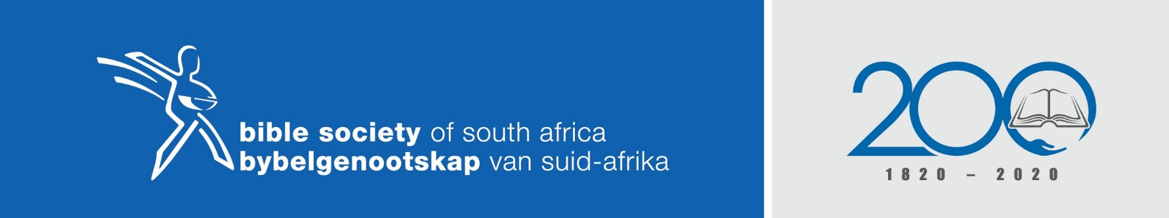
THE BIBLE – HOPE FOR ALL
Scripture reading: 2 Kings chapters 22 and 23
Theme: The hidden treasure
Author: Terry Rae (Baptist Union of Southern Africa)
Sermon outline
After a series of godless kings over Israel and Judah, Josiah becomes King of Judah at the age of 8. With the influence of a Godly mother “He did what was right in the eyes of the Lord..” 2 Kings 22 vs 2
However the books of the law had been lost and Israel and Judah had strayed way off the Scriptures in both faith and behaviour incurring the wrath of God.
- PRESERVATION.
God had preserved his word of the law, hidden in the Temple in Jerusalem. This book was found and brought to Josiah. 2 Kings 22 vs 8-10
The Bible is God’s word and He has preserved it down the ages even when mankind has ignored it; lost it; tried to destroy it; undermine it and change it.
Diocletian (284-316), the Emperor of the Roman Empire just before Constantine, published royal edicts commanding that Christian churches be destroyed and the Scriptures be destroyed by fire. A few years later he declared that the Bible had been wiped off the face of the earth.
Voltaire, the French atheist, who died in 1778, tried to destroy the Bible. He made a prediction that within one hundred years the Bible and Christianity would have been swept from existence into oblivion.
Earlier Biblical scholars proposed a theory that there were 3 different Isaiah’s who prophesied; all contained in the book of Isaiah. The theory was based on the fact that three names for God was used at different times through the book and that the book dealt with 3 different periods of history; before the exile to Babylon, during the exile in Babylon and the period after the exile. It seemed that prophecy was not accepted as prophecy. When the Dead Sea scrolls were first discovered in 1947, the 19 Isaiah Scroll found were relatively intact and are 1000 years older than any previously known copy of Isaiah. In fact, the
scrolls are the oldest group of Old Testament manuscripts ever found. They show no division and no evidence of redaction (being carved up into three sections, or compiled from 3 sections.) Most Theological institutions have dropped this theory from their curriculums.
Heaven and earth will pass away but my word will not pass away. (Matt 24:35)
As in Josiah’s time, God has preserved His word for ears that will hear and hearts that will believe.

- REVELATION.
The discovery of the book of the law (Tora or Pentateuch) by Josiah, brought into focus once again the Revelation of God. Who He is and what He expects of His people.
2 Kings 22 vs 13 revealed the anger of God towards evil and disobedience. The Covenant (2 Kings 23 vs 2) was read in the hearing of all the people and the commandments “You shall have no other Gods before me. You shall not make for yourself an idol. You shall not bow down to worship them” (Deut 5 vs 6-10) must have been a hammer blow to the people who had totally gone over to idolatry.
The revelation of God in the newly discovered Scriptures led to repentance and a complete change of practice in faith and behaviour.
- ILLUMINATION.
As a result of Josiah’s repentance demonstrated in the ripping of his garments, (2 Kings 22 vs 11) and the realisation of the nation’s disobedience (2 Kings 22 vs 13) a radical clean-up of the worship and behaviour practices of the nation took place. Chapter 23 is a summary of what needed changing that had been brought to light by the Scriptures. Baal and Asherah articles (vs 4); Sun moon and star worship (vs 5); Male prostitutes (vs 7); the terrible child sacrifices to Molech (vs 10); horses and chariots dedicated to the sun (vs 11) and the household idols together with mediums and spiritists (vs 24). These mediums and spiritists still found in our world today have trapped thousands of people in there devil craft.
We can see how far from the true worship of God they had strayed.
The Scriptures are a lamp to our feet and a light to our pathway (Psalm 119 vs 105) but when they are neglected, they lead to dark practises and unloving attitudes to each other. So many today totally disregard the Bible as a dusty old meaningless book with no relevance to our present modern world. If only they realised that we need to search the Scriptures, “for these are the Scriptures that testify about me” said Jesus (John 5 vs 39). He has the words of life, we can turn to no other.
- CELEBRATION.
After the Scriptures were rediscovered and the evil practices were done away with, it was time for celebration. (2 Kings 23 vs 21). It began with the celebration of the Passover, remembering that the Lord had rescued them from slavery in Egypt as they were found under the blood of the lamb that was splashed on the lintel and doorposts and that God had brought them into the land He promised them.
The discovery of the truth about Jesus our sacrificial lamb as revealed in the Bible brings great celebration, not only to the Angels but to all in the family of Jesus Christ.
“Let the WORD of Christ dwell in you richly as you teach and admonish one another with all wisdom, and as you sing psalms, hymns and spiritual songs with gratitude in your heart to God.” (Col 3 vs 16)

--------------------------------------------------------------------------------------

