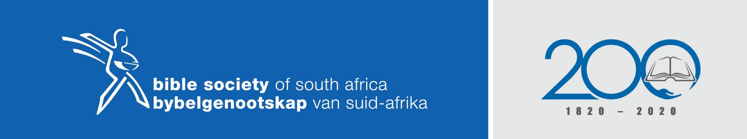
THE BIBLE HOPE FOR ALL
SCRIPTURE READING: Genesis 38:12-19; Mark 14:22 & 1 Corinthians 11:24
THEME: Woman find you strength in the Word and claim your human rights.
AUTHOR: Ruth Jonas (Methodist Church)
PURPOSE: The Bible gives evidence of women stories, which encourages women and gives them hope to stand firm in the midst of gender-based discrimination and abuse.

SERMON OUTLINE:
INTRODUTION
The reference/retelling of a current gender-based violence story as read from a tabloid. The scourge of violence, killings and discrimination against women is still happening and continuous at a high speed, despite our yearly commemoration of 16 days of activism against gender-based violence.
SERMON CONTENT
- The body is made in the image of God
The Word is the first authority and contains the only measure whereby all other truth is tested.
The story of Tamar shows that the body becomes a prominent object of power.
This story of Tamar in relation to the reflections of Paul in the Word counteracts the societal tendencies, which view the body as a thing of indulgence or as an instrument of manipulation.
The story of Tamar shows us that the body including its sexuality is a gift from God, but should be used responsibly.
This scripture bares references that the body in its male and femaleness is created in the image of God and is God’s product.

- The body as the image of God refers to people’s sexuality, which includes sexual functioning.
The existence of a human being is accomplished in the comprehension and affection of the embodied God in spiritual union with people (Kritzschmar and Hulley, 1998:14).
The text shows the immoral manner of the use of the body for the purpose of only one person who does not respect the sexuality of the other.
To restore the female body as a wonderful blessing from God.
People in relationships should treat one another with reverence and awe, and as counterparts.

- The female body just like men’s body should be valued as God’s gift.
Jesus came as a gift to the world and His death and resurrection as part of reconciling people with God.
The “Eucharistic meal” (Holy Communion) as instituted by Jesus became the symbol and gift of the body.
Women can read the Bible from the perspective that the female body is valued as God’s gift.
The Bible could be used to challenge the church that the body of Christ (which is also referred to as the church) needs to protect the rights of women.
APPLICATION OR MAIN MESSAGE
All women need to mindful to stand on the Word of God in our current experiences of a male-dominated society.
Jesus is still in solidarity with women, who suffers abuse and disrespect.
The understanding of the message of the Bible is that God cares and that He fully aware of women’s situation.
God is still able to lead gently women out of their misery and pain.

